Course: CSE 204 – Computer Networks
LAB 8 – Review
Due date: December 13th, 2025

Student name | Phan Ngọc Hanh Nhi
Student ID | 2131209002

Objective
- Implementing VLAN and VLAN Trunking
- Implementing DHCP
- Implementing Static Routing and Dynamic Routing
- Implementing Static NAT, Dynamic NAT and PAT

Assignment list
II.1. Implementing VLAN and VLAN Trunking
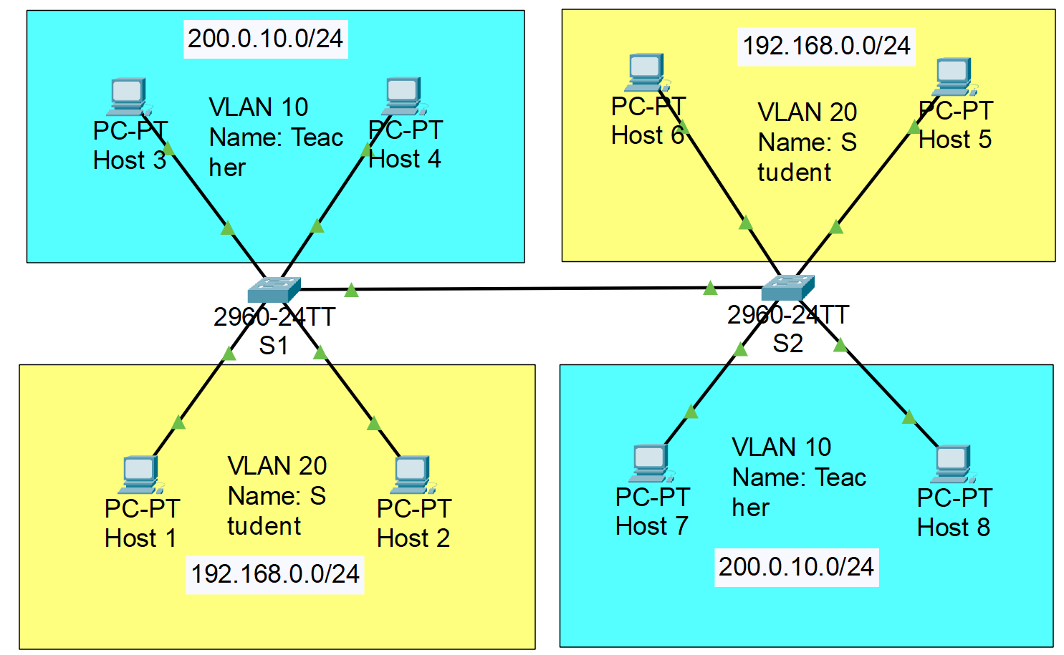
- Note: VLAN 10: port 3, 4. VLAN 20: port 10, 11. Trunk: port 1
- Configure VLAN as shown in the figure above. Then, implement VLAN Trunking on 2 Switches, so that 2 PCs in the same VLAN, but different Switch can ping each other.
- Step 1: Configure IP for all PCs
- Step 2: Create VLANs on 2 Switches S1 and S2

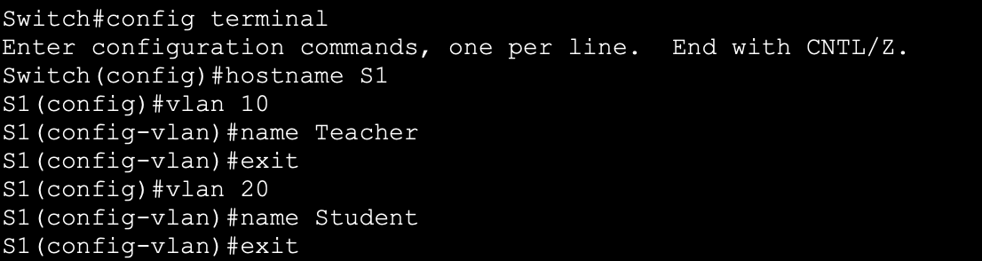
  - Repeat these steps on Switch S2. Result:
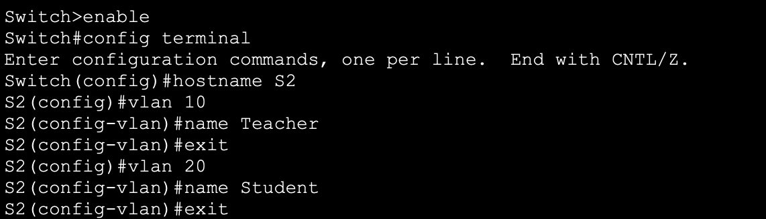
- Step 3: Assign ports to VLAN 10 and VLAN 20 on Switch 1
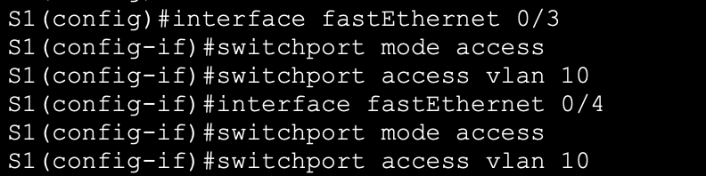
  - Repeat these steps for VLAN 20. Result:
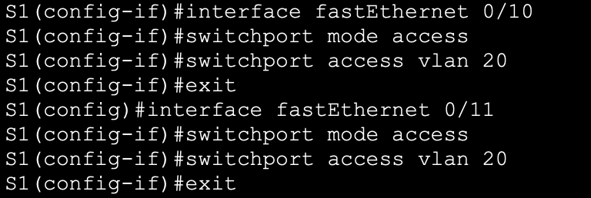
- Step 4: Assign ports to VLAN 10 and VLAN 20 on Switch 2.
  - Result:
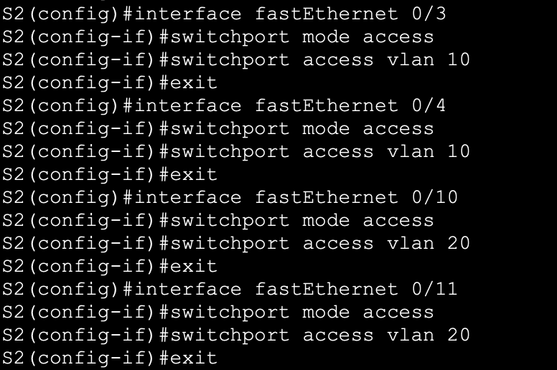
- Step 5: Check connection between PCs
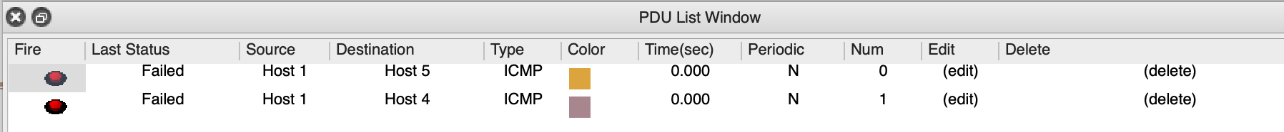
- Step 6: Create Trunk ports
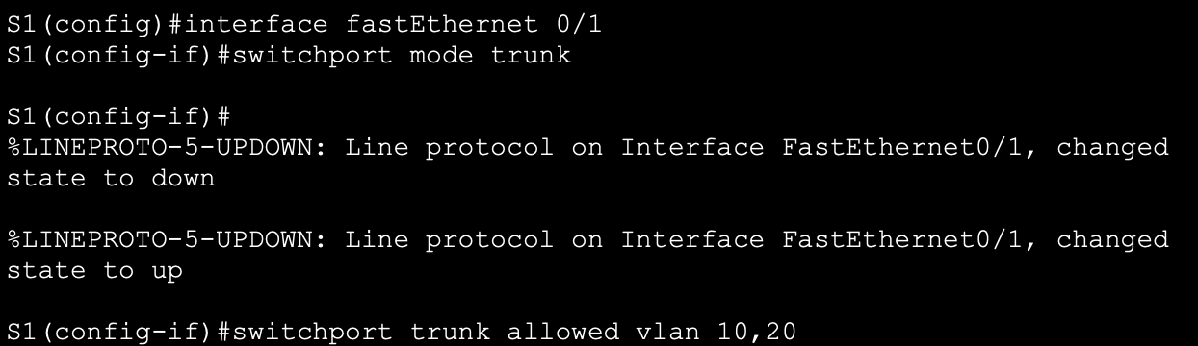
  - Repeat these steps on Switch S2. Result:
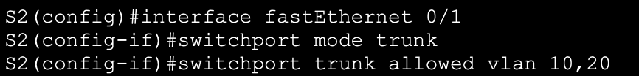
- Step 7: Check connection between PCs after creating Trunk ports
II.2. Implementing DHCP
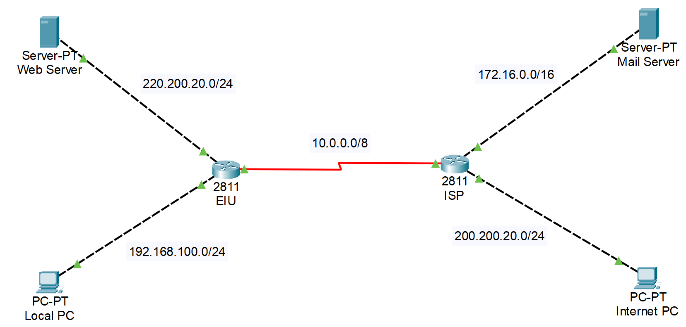
- Configure DHCP in each router based on the given information in the figure above. Result of each steps:
- On the Router:
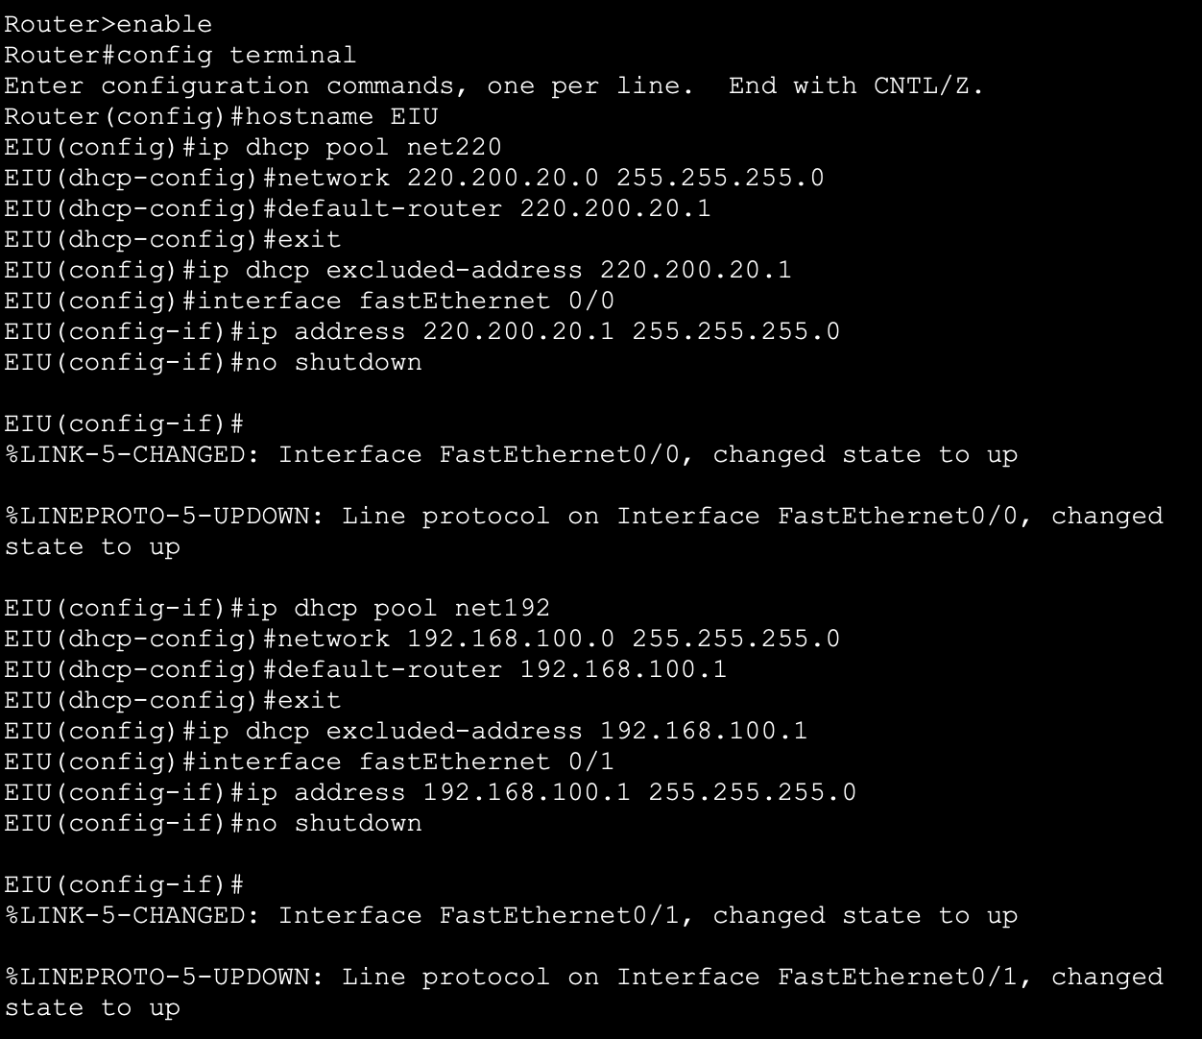
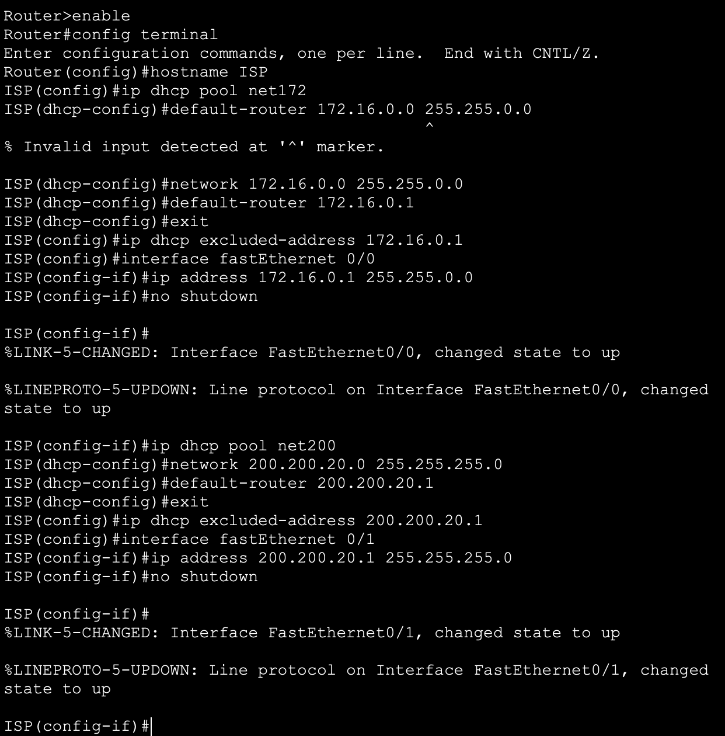
- On the PCs
On PCs, set DHCP on.
Result:
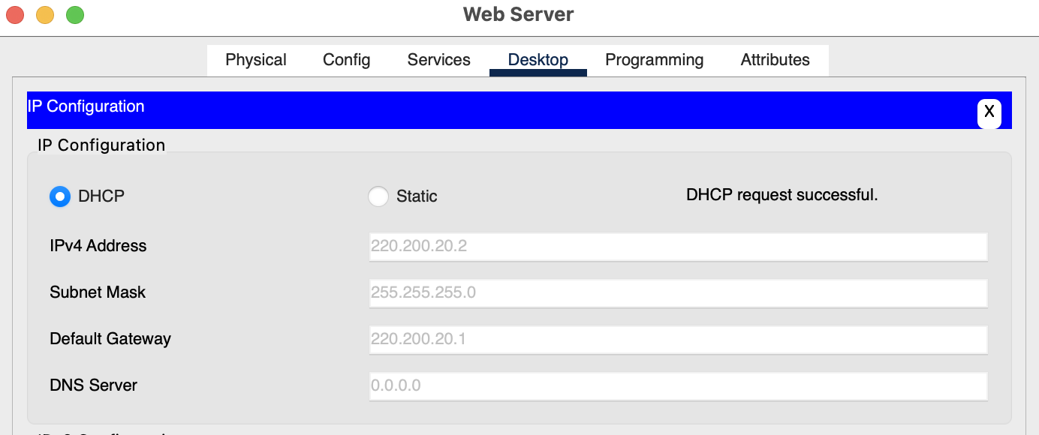
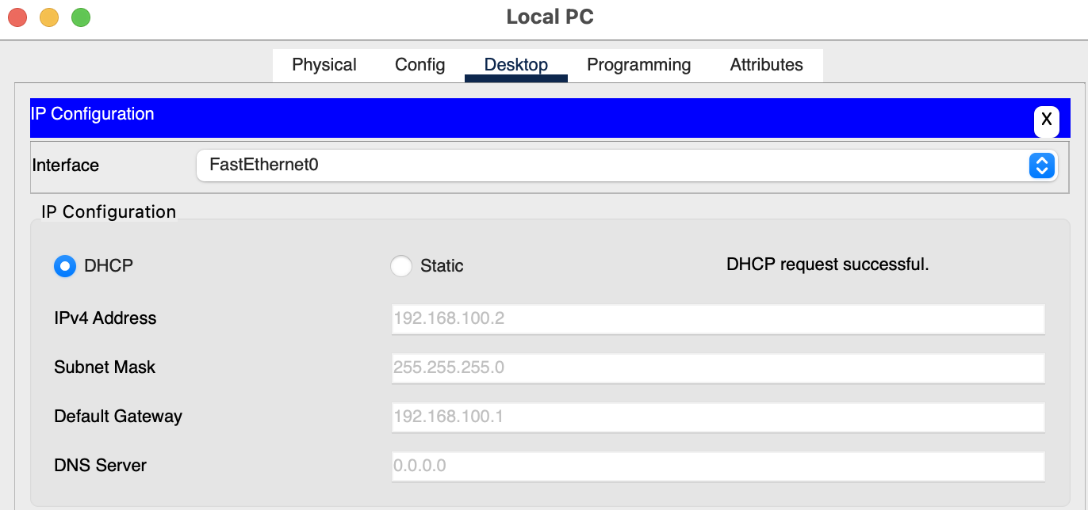
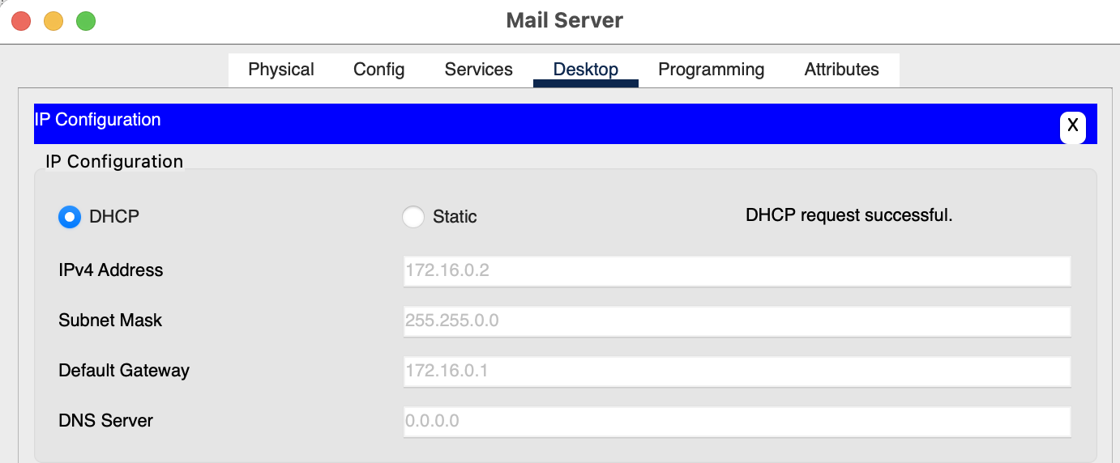
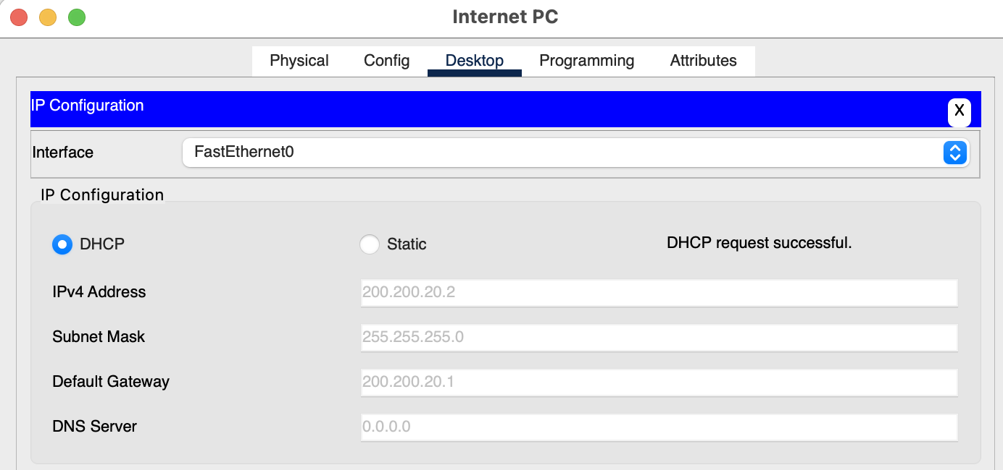
c) Configure connection between 2 routers
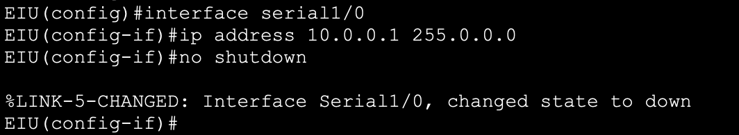
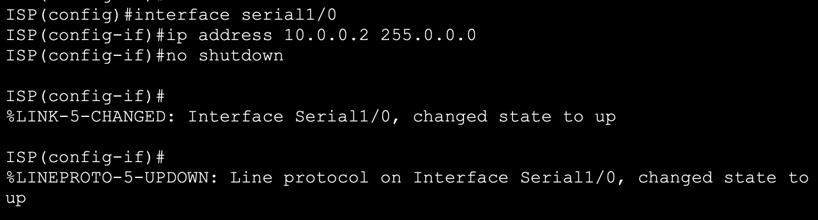
II.3. Implementing Static Routing and Dynamic Routing
- Configure DHCP in each router based on the given information in the figure above. Then configure static routing and dynamic routing so that all of the devices can ping to each other.
- Note: Please use 2 different models to configure static and dynamic routing.
- Show the results of each steps:
3.1. Static Routing:
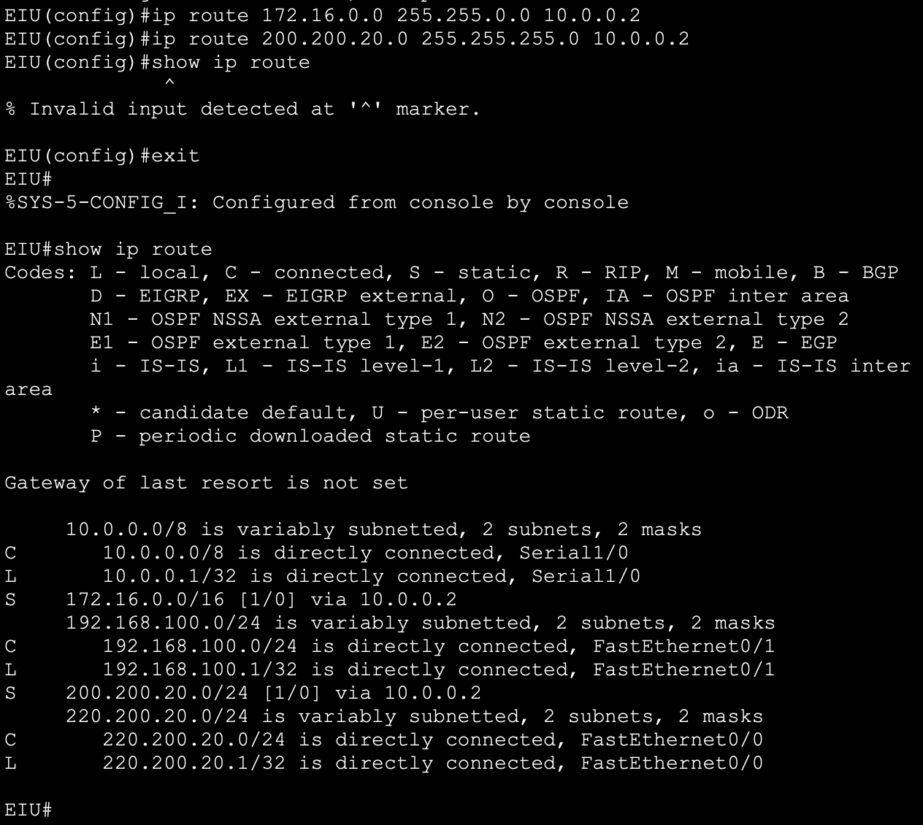
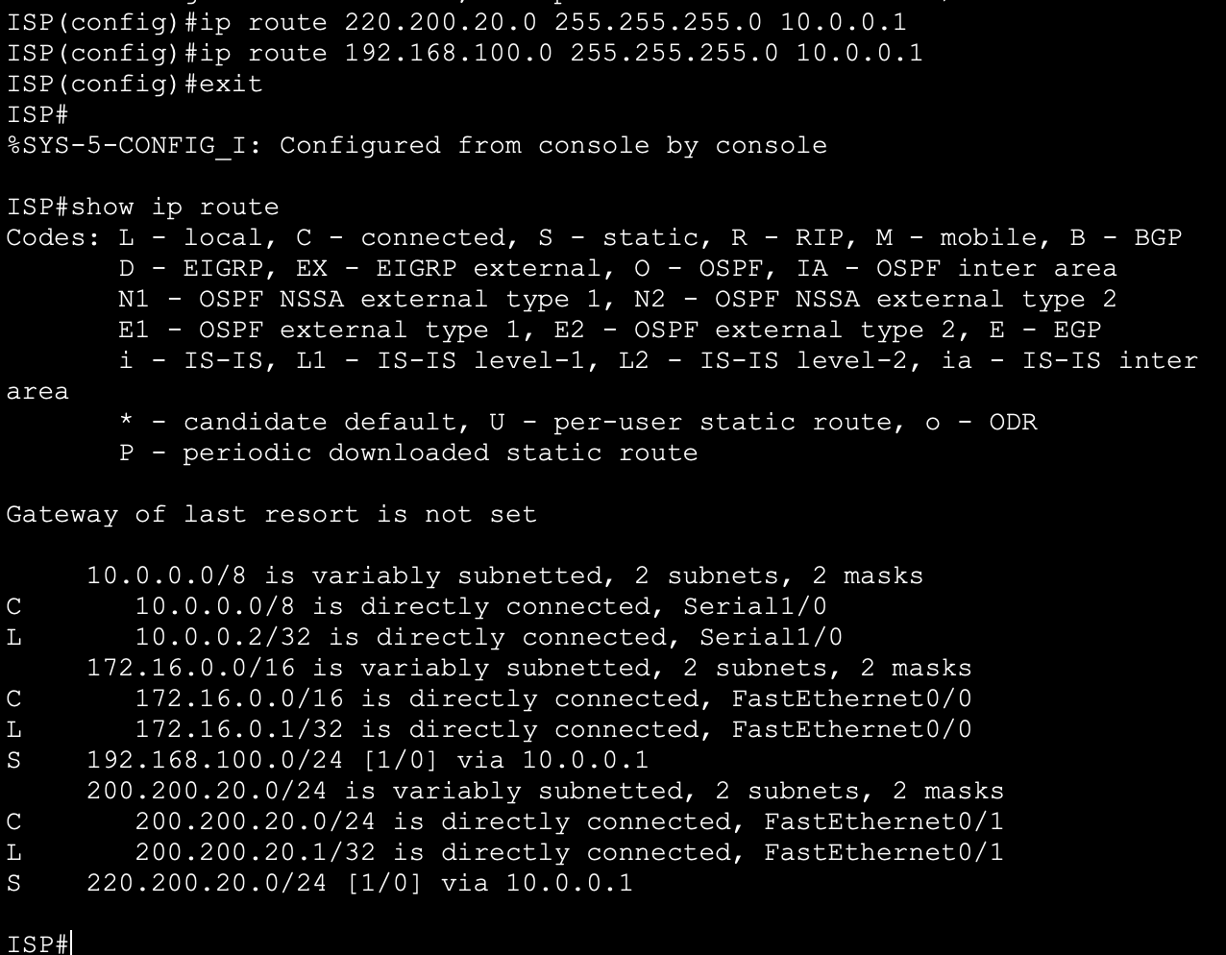
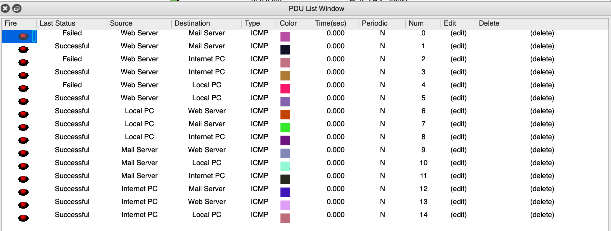
3.2. Dynamic Routing
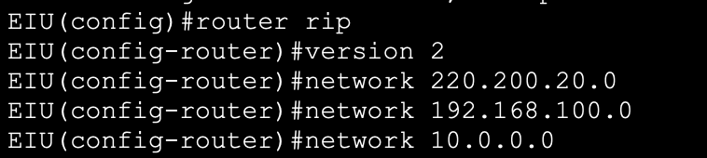
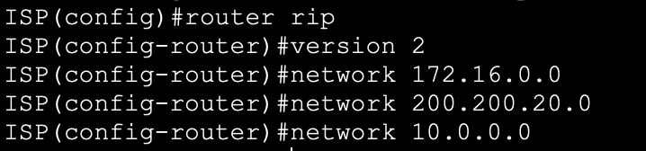
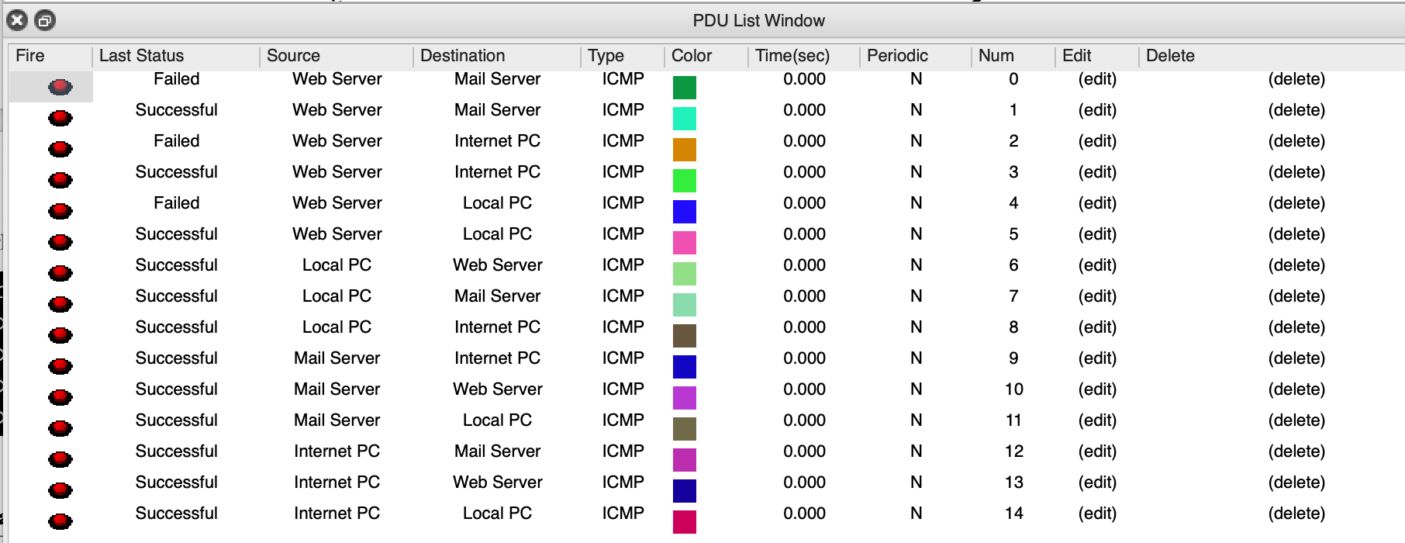
II.4. Implementing Static NAT and Dynamic NAT
- Configure DHCP in each router based on the given information in the figure above. Result of each steps:
- On the Router:
- On the PCs
On PCs, set DHCP on.
Result:
c) Configure connection between 2 routers
- Static NAT
- Assume that Router R1 can use the IP address range 199.99.9.3/24. Using Static NAT at Router R1 to translate IP address of Storage Server to public IP address. Show the results of each steps:
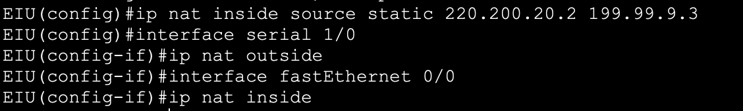
- Configure static routing on router ISP to the NAT address:
- Configure default route on router EIU:
- Check the IP NAT translation.
EIU#show ip nat translations
- Result:
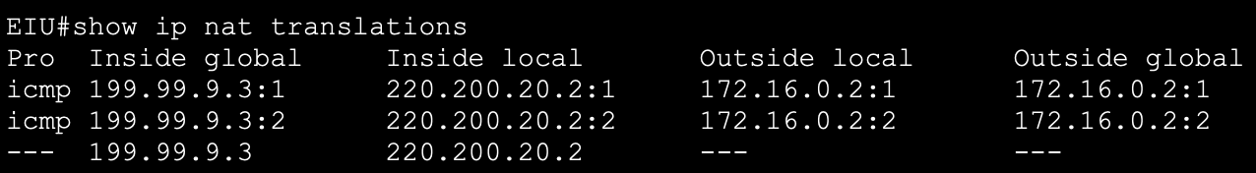
- Dynamic NAT
- Assume that Router R1 can use the IP address range MyPool 199.99.9.33 to 199.99.9.62/27). Using Dynamic NAT at Router R1 to translate local IP address of Web Server to MyPool. Show the results of each steps:
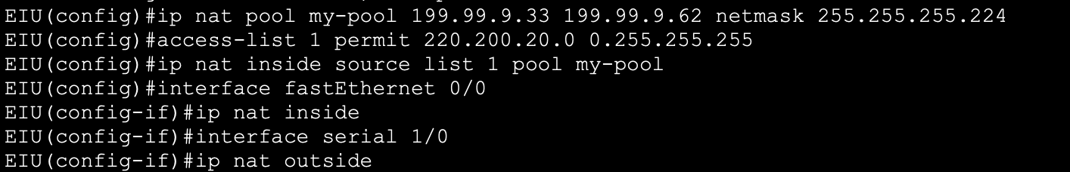
- Configure static routing on router ISP to the NAT address:
- Configure default route on router R1:
- Check the IP NAT translation.
EIU#show ip nat translations
- Result:
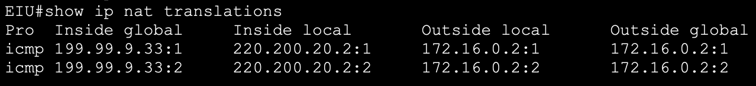
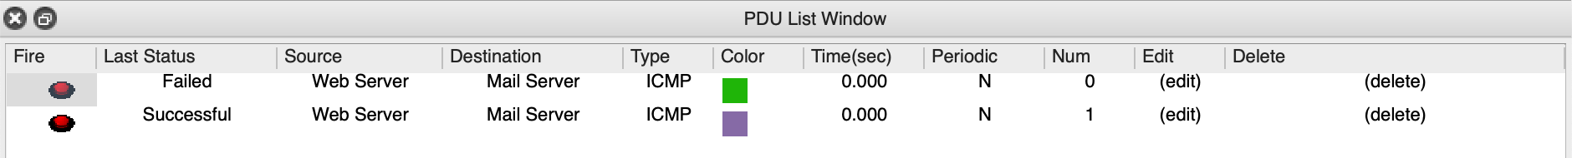
- PAT
- Configure PAT at Router EIU to translate local IP address of Web Server to public IP. Show the results of each steps:
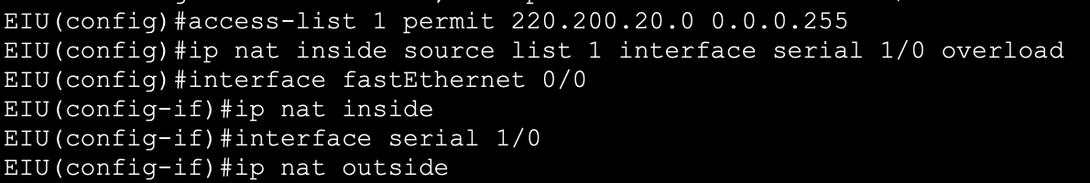
- Configure default route on router EIU:
- Check the IP NAT translation.
EIU#show ip nat translations
- Result:
